Web Programming

Laboratory Weekly Report

Week 4

**Project – Library Management System**

Aim: To design a functional library management system

Techniques Used: HTML, PHP

Procedure:

1. login.php: this is the login page of the system. It contains fields such as:
   1. Prompt for user name(email id)
   2. Prompt for password
   3. A forgot password functionality
   4. A hyperlik to “Create an account”

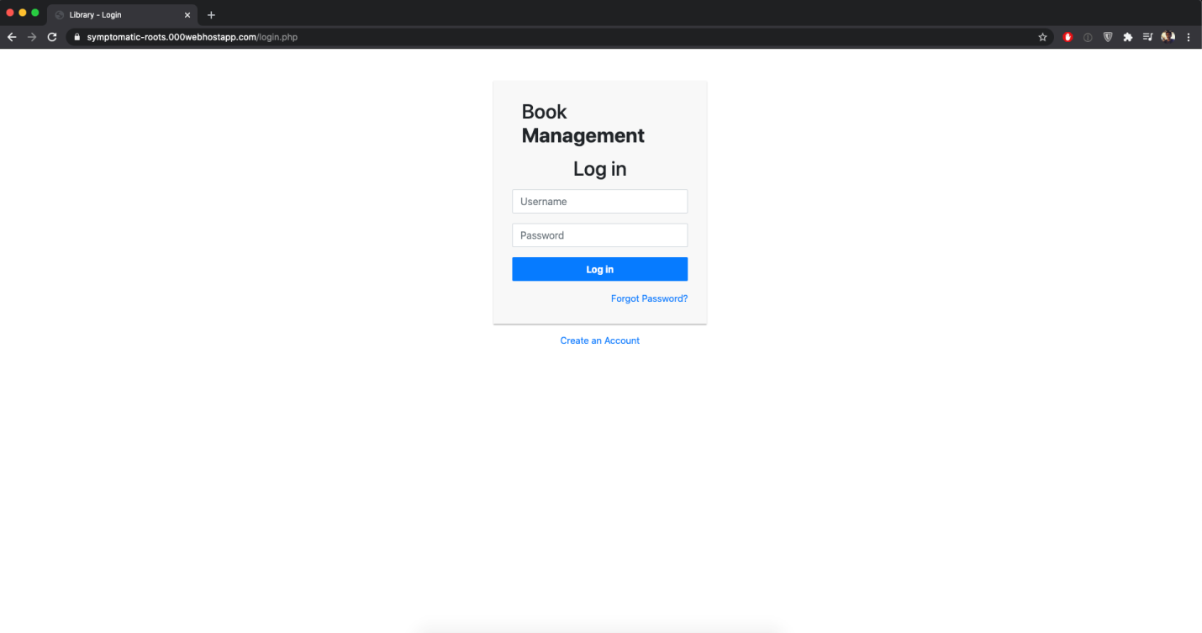

1. logout.php: When clicked on the log out button, the session is destroyed and returns to the “login.php” page.

The code is:

|  |
| --- |
| <?php |
|  | session_start(); |
|  | // Destroy session |
|  | if(session_destroy()) { |
|  | // Redirecting To Home Page |
|  | header("Location: login.php"); |
|  | } |
|  | ?> |